Warning – Cloud Enhanced Distance to Empty (CE-DTE) – BEV – FNV2

Functional Description

Cloud enhanced DTE looks at environmental and route planned factors to determine more accurate DTE than vehicle DTE. New warning messages will help to explain to customer, why DTE jumped based on various driving conditions determined by cloud and vehicle
Cloud Enhanced DTE will calculate only when there is a destination in the navigation system. DTE might differ from vehicle DTE depending on the road conditions and whether the climate control is on/off and we would like the customer to understand the change.

The Cloud-Enhanced Distance-to-Empty (Connected Vehicles) function calculates the most accurate and consistent Distance-to-Empty estimation possible for a vehicle to alleviate range anxiety and eliminate failures to reach charging locations. In doing so, it shall consider the fluctuation of current or projected traffic, weather, driving history and elevation along the projected driving route. It will do this by using a cloud-based micro-service algorithm and data learned from the vehicle.

The CEDTE Warnings correlates CAN signals DteVehOffstMsgTxt_D_Rq and Operational Mode to display various Warnings to indicate the status of the system to the driver.

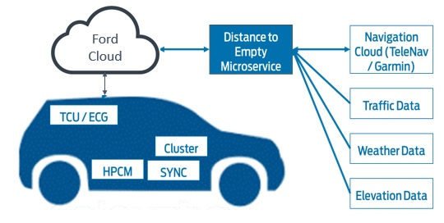

Figure 1: Cloud-Enhanced DTE Overview

Interfaces

Interface Context Diagram (I/O Block Diagram)

CE-DTE Context Diagram
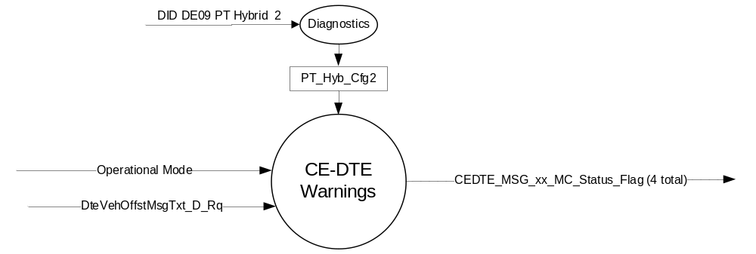

Inputs

- Internal:
Operational Mode

- Mux Signals
- DteVehOffstMsgTxt_D_Rq Signal
Signal Name | Size (bits) | Detail | Units | Res. | Offset | State Encoded | Min | Max
DteVehOffstMsgTxt_D_Rq | 4 |  | unitless | 1 | 0 |  | 0  (0x0) | 15  (0xF)
 |  | No Message |  |  |  | 0x0
 |  | Destination Route |  |  |  | 0x1
 |  | Hilly Terrain |  |  |  | 0x2
 |  | External Temperature |  |  |  | 0x3
 |  | TrafficAlongRoute |  |  |  | 0x4
 |  | TrailerTowing_On |  |  |  | 0x5
 |  | TrailerTowing_Off |  |  |  | 0x6
 |  | Payload |  |  |  | 0x7
 |  | PowerToTheBox |  |  |  | 0x8
 |  | NotUsed_1 |  |  |  | 0x9
 |  | NotUsed_2 |  |  |  | 0xA
 |  | NotUsed_3 |  |  |  | 0xB
 |  | NotUsed_4 |  |  |  | 0xC
 |  | NotUsed_5 |  |  |  | 0xD
 |  | NotUsed_6 |  |  |  | 0xE
 |  | NotUsed_7 |  |  |  | 0xF

Outputs
- Internal:
  - CEDTE_MSG_xx_MC_Status_Flag, which is used to control the state of the CEDTE warning messages.
(xx = 1, 2, 3 & 4)

Function/Performance

Operational Modes

Mode | Differentiating Vehicle Conditions
Sleep Mode | CEDTE_MSG_xx_MC_Status_Flag(s) = Inactive
Limited Mode | CEDTE_MSG_xx_MC_Status_Flag(s) = Inactive
Normal Mode | CEDTE_MSG_xx_MC_Status_Flag(s) = Inactive/Active
Crank Mode | CEDTE_MSG_xx_MC_Status_Flag(s) = Inactive/Active

Voltage Levels

Refer to the Cluster Features table located in the Operational Modes and Voltage Range Strategies Section in this SPSS.

Human-Machine Interface

Visual

Indicator Graphics / Display Format
Refer Global Message List (GML) for Text and Display.
Reference the Message IDs in the Text Message List file for the appropriate displays.

Indicator Color Coordinates

Reference section COLOR & ILLUMINATION REQUIREMENTS (GRAPHICS)

Indicator Characteristics

Refer to Message Center X Display_Y Button Interface Section, where X and Y are appropriate values in this document.

Audio

None

Switch Control Logic

Refer to Message Center X Display_Y Button Interface Section, where X and Y are appropriate values in this document, for System Check and Warning behavior.

System Accuracy

Within 100 ms of receiving a message that results in a change of state the cluster will update the display to the proper state.

Operation: Performance and Functional

Subsystem Algorithm Flowchart / State Diagram

- State Matrix for CEDTE MC Status Flags
Operational_ Mode | PT_Hyb_Cfg2 | DteVehOffstMsgTxt_D_Rq | CEDTE_MSG_1_MC_Status_Flag | CEDTE_MSG_2_MC_Status_Flag | CEDTE_MSG_3_MC_Status_Flag | CEDTE_MSG_4_MC_Status_Flag
Normal or Crank | BEV(0x1) | No Message (0x0) | Ina | Ina | Ina | Ina
Normal or Crank | BEV(0x1) | Destination Route(0x1) | ACT | Ina | Ina | Ina
Normal or Crank | BEV(0x1) | Hilly Terrain(0x2) | Ina | ACT | Ina | Ina
Normal or Crank | BEV(0x1) | External Temperature(0x3) | Ina | Ina | ACT | Ina
Normal or Crank | BEV(0x1) | TrafficAlongRoute(0x4) | Ina | Ina | Ina | ACT
All Other Cases |  |  | Ina | Ina | Ina | Ina
X = don’t care, Ina = INACTIVE, ACT = ACTIVE

- CEDTE Warning MC Status Flags to MC Warning Message ID
MC_Status_Flag | Mc Warning Message ID | Text ⁽¹⁾ | Active Chime_Status_Flag⁽²⁾
CEDTE_MSG_1_MC_Status_Flag | W4314 | Electric Range  Revised Due to  Destination Route | None
CEDTE_MSG_2_MC_Status_Flag | W4315 | Electric Range  Revised Due to  Hilly Route | None
CEDTE_MSG_3_MC_Status_Flag | W4316 | Electric Range  Revised Due to  External Temperature | None
CEDTE_MSG_4_MC_Status_Flag | W4317 | Electric Range  Revised Due to  Route Traffic | None
- Text shown for reference only. Text message list is the master. Supplier to advise Ford of any discrepancy.
- Chime column matches the global text message list. Supplier to advise Ford on any discrepancy.

Operation Description (supports algorithm flowchart /state diagram)

None

Function Safety Classification (EMC)

B

Memory Storage
Parameter Name | Description | Value at  Battery Connect | Value at  Module  Wake-up
CEDTE_MSG_1_MC_Status_Flag | Used to control the state of the warning to the Message Center arbitrator | INACTIVE (0x0) | INACTIVE (0x0)
CEDTE_MSG_2_MC_Status_Flag | Used to control the state of the warning to the Message Center arbitrator | INACTIVE (0x0) | INACTIVE (0x0)
CEDTE_MSG_3_MC_Status_Flag | Used to control the state of the warning to the Message Center arbitrator | INACTIVE (0x0) | INACTIVE (0x0)
CEDTE_MSG_4_MC_Status_Flag | Used to control the state of the warning to the Message Center arbitrator | INACTIVE (0x0) | INACTIVE (0x0)
CEDTE_MSG_5_MC_Status_Flag | Used to control the state of the warning to the Message Center arbitrator | INACTIVE (0x0) | INACTIVE (0x0)
DteVehOffstMsgTxt_D_Rq | CAN signal sent from the PCM | No Message (0x0) | No Message (0x0)
Operational_Mode | 4 state indicator for cluster operational mode | Limited | Limited or Normal or Crank

Prove Out

No

Reconfigurable Telltale

No RTT.

Message Center Message

Warning Message ID W4314, W4315, W4316 and W4317 as defined in the Text Message List section of this SPSS.

Error Handling

Missing Message Strategy

The signals will be declared missing as per the Diagnostics section of this SPSS.

DTCs states and history will be determined as per the Diagnostics section of this SPSS.

Diagnostics

Self Test

None

Engineering Test Mode

Reference section “Dealer / Engineering Test Mode (ETM)”

Part II Performance

Supported Diagnostic Trouble Codes (DTCs)
DTC | Description | When Logged
None

DID DExx
Block  Num | Block Description | Byte(s) | Bits | State: Description | "0" | "1" | Default | Comments/Information
PACKETED BLOCKS
$09 | Option Content (B&A) |  | 3 | PT Hybrid2(PT_Hyb_Cfg2)  0x0 = Non-Hybrid  0x1 = BEV  0x2 = FHEV  0x3 = PHEV  0x4 = MHEV |  |  | 0x0 | Default from cluster plant to be 0x0 if cluster can be used on a Non-Hybrid.
 | *Byte and bit location to be identified in Part II Specification for this cluster

Reference Specification

Revision History
SPSS Module Revision History

Revision Level | Name | Change Description | Date
1.0 | H Sharma | Initial release – This was approved in DICC on 08/01/2019 and brought to DICC by Charbel Bouery & Ryan Hunt. This initial release is planned for P702 and Cx727 programs. DICC Tracking Number #315 | 09/27/2019

